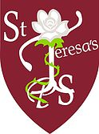
St. Teresa’s Primary School
“Doing ordinary things extraordinarily well”

Summer Newsline 2023
Parents / Guardians,
COVID-19 Regulations
We will be relaxing our one-way system around the school in September 2023, so you will be able to collect your child via either gate at 2pm & 3pm pick up times.
New School Arrangements 2023/2024
School will start at 9am each morning during the week (not 9.10am), in August/September. School will also finish at 2pm every Friday for all children to allow staff time to accommodate scheduled meetings and adequately planning for the week ahead. School will finish at 3pm Monday – Thursday as normal.
Communication
Seesaw – each class will continue with this in September. All teachers will keep in touch with parents / guardians via the Seesaw App. Please make sure you are signed up to your child’s teacher / class.
School App – for messaging / forms / bookings / payments this will continue in September
School Website – for ‘whole school’ information will continue in September
Newsline – will continue in September
Text Service – WILL STOP due to lack of funding
Food Allergies / Healthy Break
Can I ask you to adhere to precautions we have in school for children with severe allergies? To date we have 3 children (who require epipens) and can I ask that NO nuts or fish are brought into school at ANYTIME. As we are a healthy eating school we require our children to bring in water, fruit or vegetables to eat / drink at breaktime. We hope to see an improvement in concentration and behaviours as we move forward together on this.
Absences from school
Absences from school during term time are discouraged and will affect your child’s attendance rate. If your child’s attendance rate falls below 85%, the ‘Education Welfare Officer’ will contact you or pay a visit to your home. If you do need to take your child out of school, please notify Mr. Kearney in writing. (This does not include days of sickness; you can notify school about sickness using the Absence Form on our school app).
Music Service
Due to budget restraints, a letter will be issued to Parents over the next few weeks, if they wish for their child to partake in ‘core music lessons (Individual). Whole class lessons ‘Pathways teaching’ are part of the curriculum. Money will have to be paid in full, in order to secure the services of an EA Music Tutor for the year ahead. Fees will be issued in the music letter over the next few weeks.
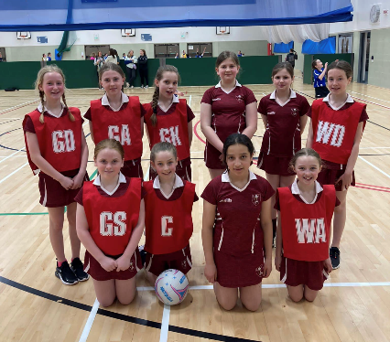
Netball Champions
Congratulations to our P7 Netball Team who won the
recent ABC competition in South Lakes LC for the
1st time in our school’s history. Our team defeated
Tannaghmore PS, St Anthony’s PS, St Francis PS, Bronte PS and
St Mary’s Banbridge PS along the way.
We wish them continued success at the Northern Ireland Finals
in Lisburn on Sat 3rd June!!!

Trocaire Campaign
Thank you for the recent fundraiser campaign in school where we collected £1000 for Trocaire. This money will go directly to help children in Health Centres in Somalia, reinforcing our rights to help others in poor countries of the world. (As we are a Rights Respecting School)
School Development Plan
Thank you for spending the time completing the questionnaires on our website. We are still in the process of collating and prioritising the data. The information will be shared with you in due course as this helps us to plan for next year (2023/2024)
Financial Help!!!! We need you!!!
I’m sure you are well aware of the challenging financial crisis affecting our school. During the month of June I will be approaching local business / companies to ask if they would be interested in supporting our school, in whatever way possible (ie) donations / or backing an individual incentive we have in place to help our children. Some ideas we need help with include School Counsellor / Literacy & Numeracy programmes / School Website / Baseline Assessment Programmes / School App which all require school monies to function. If by any chance you would like to contact Mr Kearney first in advance to support our school, please do so over the next few weeks. Thank you in advance – as all your help / co-operation is appreciated.
Summer Weather
As we are experiencing better weather at the moment, can you ensure your child has water in school, suncream applied (if required). Children may wear P.E uniforms / summer dresses too!
Key Dates: (on the calendar on school website too!)
29th - 2nd June – School closed
1st June – Lismore Testing 9am in Lismore for P7s
6th June - P3 Trip with Shared Education
6th June – St Ronan’s Gaelic Tournament at Clan na Gael GAC
8th June – Love for Life Talk (P7s)
8th June - P1 Trip with Shared Education
9th June – St Ronan’s Testing 9am in St Ronan’s for P7s
10th June – First Holy Communion (P4) St Peter’s Church at 11am (P3 Parents / Guardians asked to support)
12th June – Bee Safe Event P7s
14th June – Summer Music Concert in school at 9.30am for all children partaking in music programmes this year parents/guardians welcome
15th June – KS2 Sports Day 9.30am start (P5-P7) Parents / Guardians welcome
16th June – F/KS1 Sports Day 9.30am (P1-P4) Parents / Guardians welcome
- P7 trip to Emerald Park
- Annual reports will be sent home for all children
19th June – In House Soccer Tournament – Des Hughes Cup
20th June – In House Gaelic Tournament – Master Lavery Cup
20th, 21st & 22nd June – School Nurse for P1 Assessments
22nd June – P7 Leavers’ Assembly – 9.30am, Mass – 11am in school, P7 Celebration in St Peter’s Club from 1-3pm
24th June – FOST Fundraiser Night in Woodville Arms – Tickets available from school office £10 each
27th June – Exploris Trip P1/P2/P3 9am – 4pm
30th June – School to finish for all children at 11.30am

All newslines and dinner menus are available on the school website www.stteresaslurgan.com and School App

